**Role For Stop/Start VM in Azure**

In order to allow a user to start and stop a virtual machine you need to create a custom [role](https://docs.microsoft.com/en-us/azure/role-based-access-control/overview) with the right permissions.

* Create a JSON file with the following content (let us name it newRole.json):

{

"Name": "Virtual Machine Operator",

"IsCustom": true,

"Description": "Can deallocate, start and restart virtual machines.",

"Actions": [

"Microsoft.Compute/*/read",

"Microsoft.Compute/virtualMachines/start/action",

"Microsoft.Compute/virtualMachines/restart/action",

"Microsoft.Compute/virtualMachines/deallocate/action"

],

"NotActions": [

],

"AssignableScopes": [

"/subscriptions/11111111-1111-1111-1111-111111111111"

]

}

* A short explanation of each field of the JSON file:
  + **Name**: the name of the new role. This is the name that will be shown in the azure portal
  + **Is Custom**: specifies that it is a user defined role
  + **Description**: a short description of the role, is shown as well in the azure portal
  + **Actions**: the list of action that can be performed by a user associated to this role. Respectively each line allows the user to:
    - Start one of the virtual machine among those in the list
    - Restart one of the virtual machine among those in the list
    - Deallocate one of the virtual machine among those in the list
    - You can use the folloing link for more actions : <https://docs.microsoft.com/en-us/azure/role-based-access-control/resource-provider-operations>
  + **No Actions**: the list of action that can't be performed by a user associated to this role. In this case the list is empty, in general it has to be a subset of the previous field.
  + **AssignableScopes**: the set of your subscriptions where the role has to be added. Each code is prefixed by the /subscription/ string. You can find the code of your subscription by accessing the subscription menu
* Login to your azure account with the azure cli executing the command az login.
* Create the new role executing the command az role definition create --role-definition newRole.json.
* Access the portal and **select the virtual machine that has to be powered on and off** by a user of your choice
* After you selected the machine select Access control (Iam)

[enter image description here](https://i.stack.imgur.com/z0LVV.png)

* From the new blade select Add
* Fill in the fields as follow:
  + **Role**: Select the role you just created, in our case Virtual Machine Operator
  + **Assign access to**: Azure AD user, group, or application.
  + **Select**: the email associated to the account that needs to start/restart/stop the VM

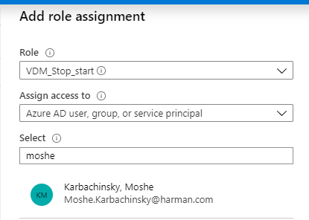

* Press save

After this operations when the user will access the portal he will see the selected VM in the list of the virtual machines. If he selects the virtual machine he will be able to start/restart/stop it.